Installing DDT – ADO on Windows PC

**Green** **bolded** code can be copied and pasted into Anaconda Prompt.

Be sure Anaconda and Python are installed. To check, go to the start menu and search for Anaconda Prompt (anaconda3). Open Anaconda Prompt and when the base line appears type **python -- and hit enter.** The version should be 3.7 or 3.7.##. To install Anaconda or install the proper version of Python follow the “Install Python” instructions in the [Technology Set-up How-To](../../../../MGH%20How-To's/Technology%20set-up%20how-to%202021.09.22.docx)

1. Go to D:\Richard\Measures Bank\Tasks\DDT (Delay Discounting Task)
2. Copy the DDT (Delay Discounting Task) - ADO folder and paste it in C:\MABL
3. Go to the start menu and open “Anaconda Prompt (anaconda3)”
4. The screen should look like 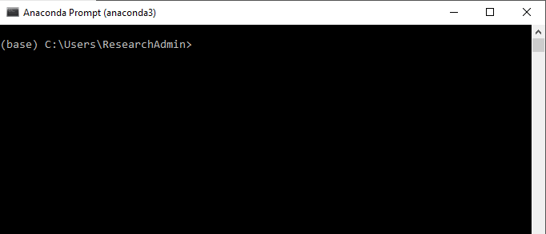
5. Type code **pip install adopy** and hit enter
6. Type code **pip install pyyaml** and hit enter
7. Type code **pip install psychopy** and hit enter
8. Type code **pip install pyinstaller** and hit enter
9. Type code **pip install poetry** and hit enter
10. Type code cd followed by the file path to the DDT files and hit enter
    1. E.g., cd C:\MABL\DDT (Delay Discounting Task) – ADO
11. Enter code **poetry install**
12. Enter code **poetry shell**
13. Enter code **pyinstaller main.py**
    1. This will create a “dist” folder with a “main” subfolder
14. Enter code **python main.py**
    1. When the window opens enter the ID and select the Wave and Prepost, click okay and then Save
    2. Run the task to check it is working
15. Go to the DDT (Delay Discounting Task) – ADO folder in the MABL folder and double click the build.bat file
    1. If a Windows protected your PC pops up, click “more info” and then click “run anyway”
    2. This will create a ddt.exe file and a ddt subfolder in the dist folder. The ddt subfolder will also contain a ddt.exe file
16. When you see (base) C:\..., go to DDT (Delay Discounting Task) – ADO > dist > ddt folder and go to the ddt.exe file. Double click to open
    1. Enter the ID, Wave, and Prepost and click okay and then save to run the task
    2. This is the preferred file to run the task as it is much quicker to open
17. Go to the dist folder and open the ddt.exe file
    1. Run the task

Congrats!! You have now successfully installed Python and the DDT 😊